

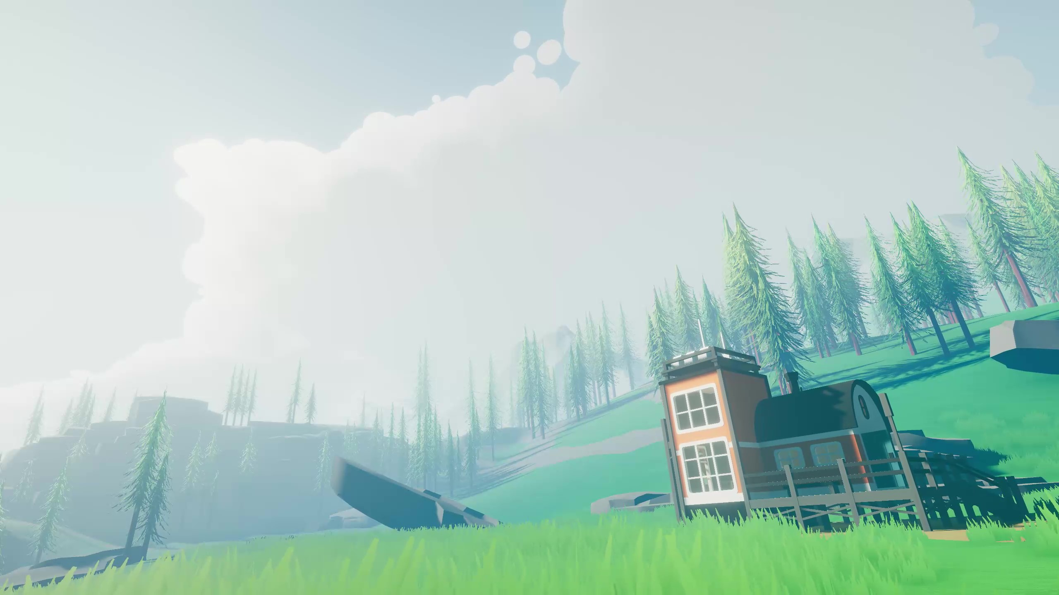

DOCUMENTATION

& USE GUIDE

**Thank you for your purchase of COZY: Weather!**

I have personally had a blast working on this project and I hope that it serves you well throughout your endeavors. I have designed Cozy to be as customizable as possible and Cozy comes with several built-in functions to help with personalization for your projects.

The purpose of this documentation is to explain all the separate functions as well as ensure proper setup. COZY: Weather is self-documented and as such most things are explained within the editor through tooltips and comments. This documentation focuses on ensuring that all the nuances of the functions are a help rather than a hinderance while you are creating your experiences. If you need any further help beyond what this documentation provides, please feel free to contact us directly. Not only will we be able to help you, but we will also be able to improve on this project through your feedback.

Best of luck as you create!

Cheers!

Keller Bowman | Distant Lands

INTRO NOTE

___________________________________________________________

Can’t find what you need here? **Get in contact with us!**

[YouTube](https://www.youtube.com/channel/UCXQh-98ACis92hNY0Qookvw)

[Website](https://distantlands.wixsite.com/distantlands)

[Discord](https://discord.gg/HWGU4hj)

[Unity Page](https://assetstore.unity.com/publishers/40676)

[E-mail](mailto:distantlands.productions@gmail.com)

***This documentation is a work-in-progress. Help us expand it by leaving***

***suggestions in our Discord server!***

GETTING STARTED

____________________________________________________________________________

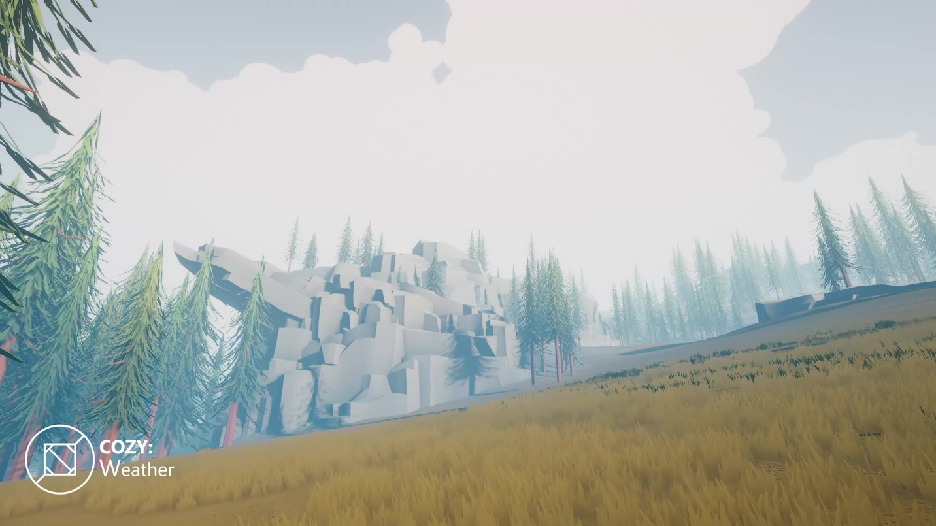

1. Setting Up Your Project

* Built-In Setup
* URP Setup
* Custom Tags, Layers, and Settings

1. Understanding The Demo Scene

* Finding the Scene
* Brief Explanations of Major Objects

1. Setting Up a New Scene

* 3 Simple Steps
* Requirements and Limits

Next up: Under the Hood

NEW TO COZY? Don’t sweat it!

This guide should make your experience with COZY as positive as possible!

________________________________________________________

SETTING UP YOUR PROJECT

QUICK TIP: This documentation is written with a BiRP focus. Certain settings may look a bit different on URP!

____________________________________________________________________________

3. CUSTOM SETTINGS

If you plan on using the *COZY Trigger System*, we highly recommend adding the tag “FX Block Zone” to your project however you can set this to any tag you like in the *COZY Trigger Module*!

____________________________________________

If using URP and experiencing pixelation effects in the fog, be sure to set the opaque texture downsampling to NONE!

2. UNIVERSAL RENDERER

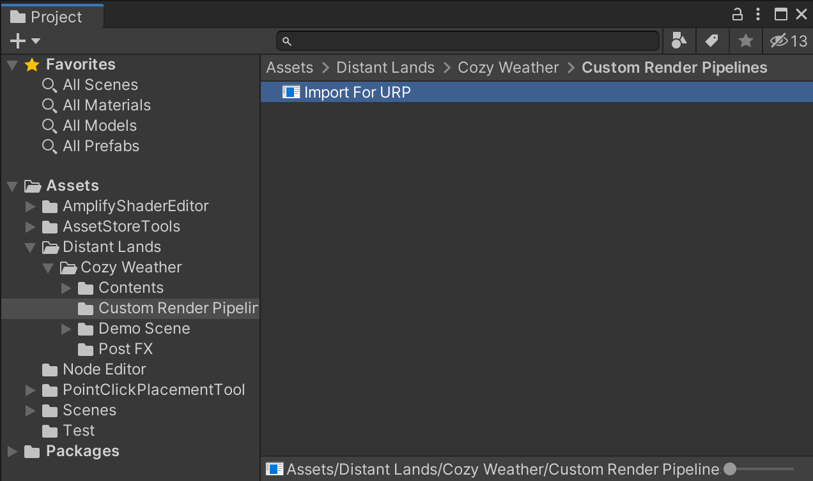

If you are running the Universal Render Pipeline, we have a separate version of COZY just for you! Import the “Import for URP package” found in the Custom Render Pipelines folder for best results.

____________________________________________

After importing, be sure to enable the depth and opaque textures in your pipeline asset! If you are using SSAO, be sure to set your SSAO source to Depth.

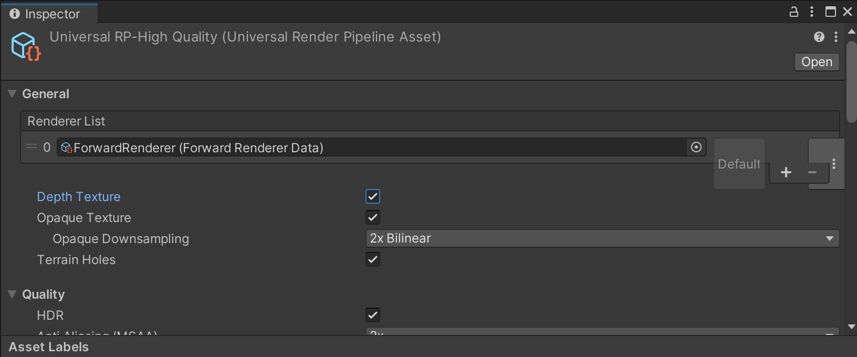

1. BUILT IN RENDERER

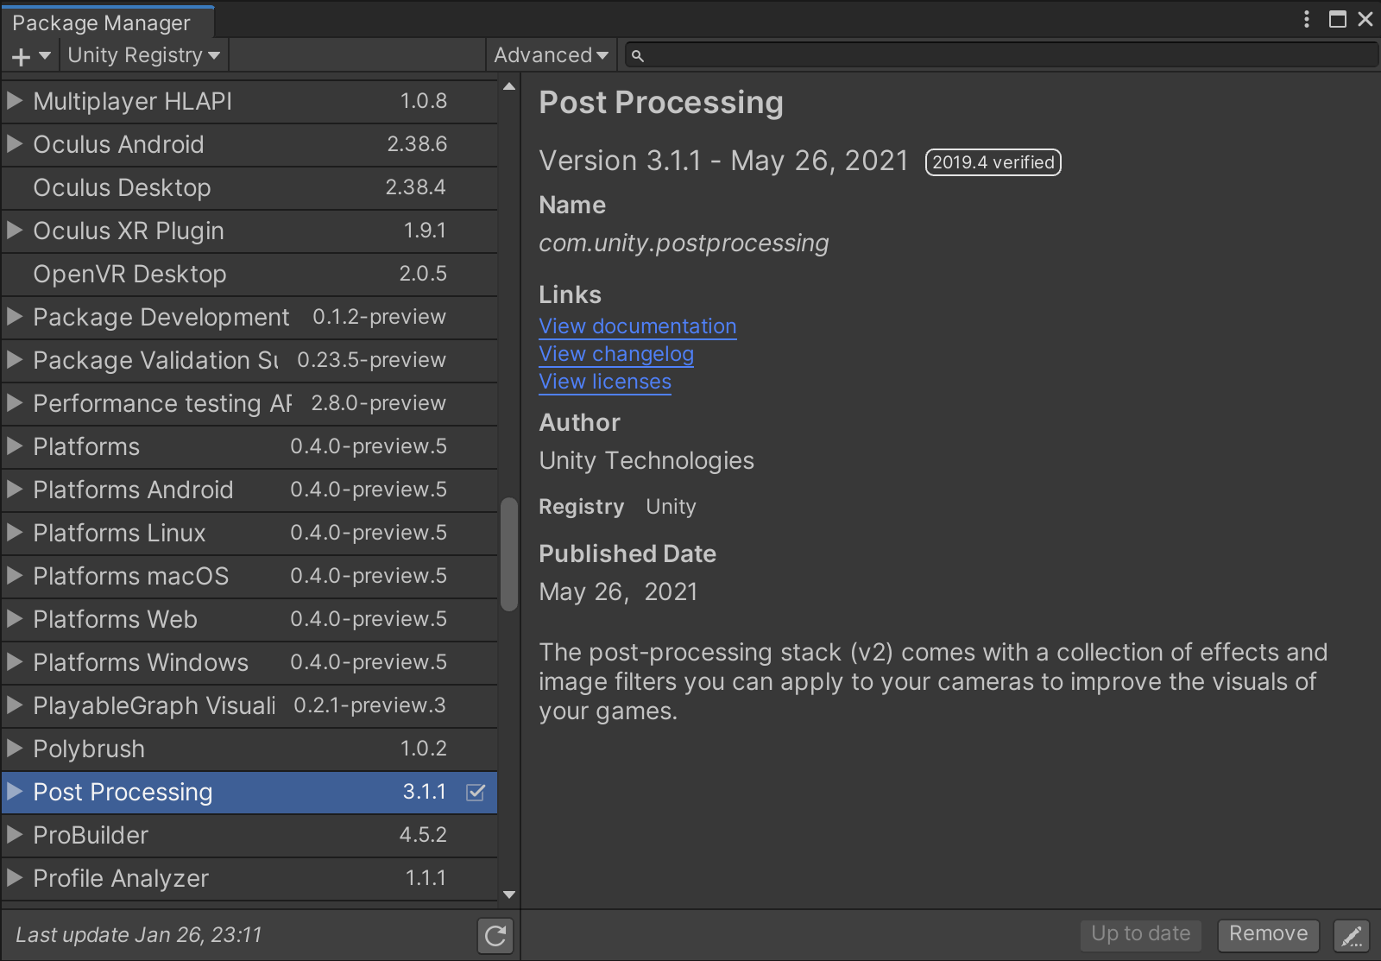

If you are running the Built-In Render Pipeline, we highly recommend importing the Post Processing package from the package manager.

____________________________________________

We also highly recommend working in the linear color space. This allows for higher color contrast and proper color placement across all your scenes—no matter the time of day!

UNDERSTANDING

THE DEMO SCENE

____________________________________________________________________________

PRESS PLAY

TO GET LOST

This scene is setup ready to work out of the box with the default COZY settings. There is a lot left to cover as far as customization goes but if you are just looking to play around and see what COZY is all about, this scene is for you!

____________________________________________

The best way to quickly get to know COZY, is through the demo scene. Start by opening the demo scene found at Distant Lands/Cozy/Demo Scene/Observation Plains.

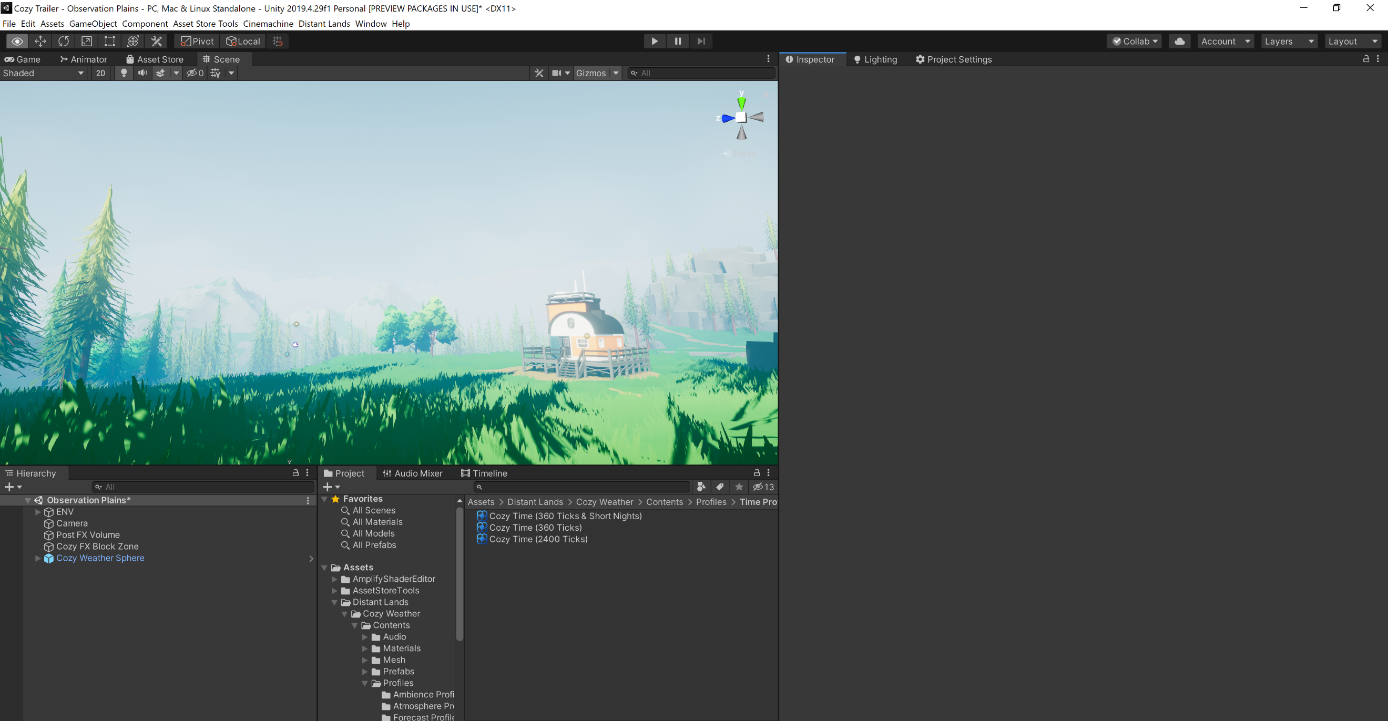

It’s important to take note of a few objects in the scene:

1.

2.

3.

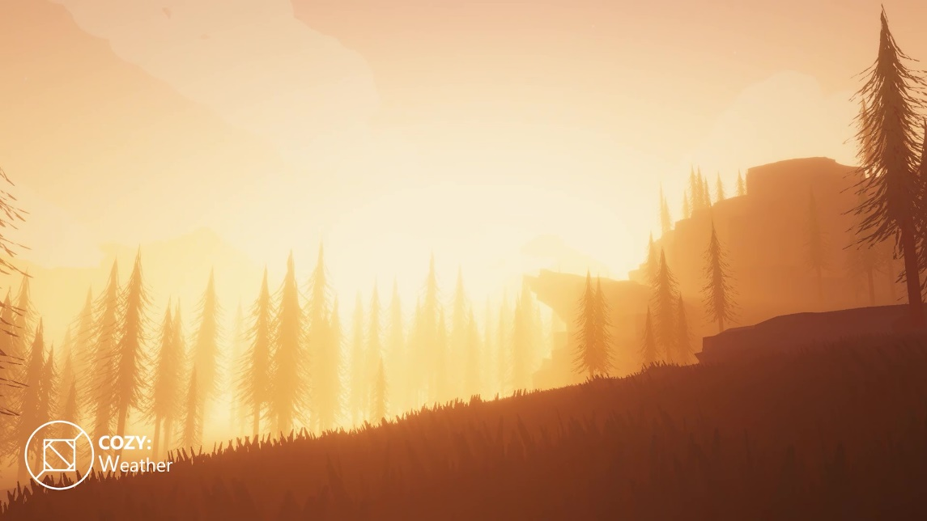

The ENV object stores all the demo meshes in the scene. This includes trees, terrain, rocks, and grass.

The Main Camera functions as the main viewport for the scene. COZY requires a main camera to function properly!

The Cozy Weather Sphere is the head unit for COZY. This object holds the sky, fog and clouds as well as manages all runtime changes

SETTING UP A SCENE

____________________________________________________________________________

COZY makes setting up a new scene incredibly easy! All you have to do is

follow 3 quick steps:

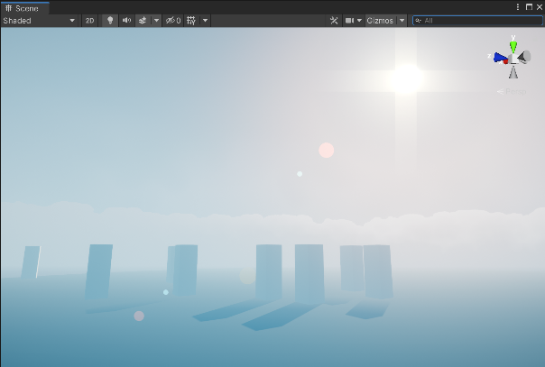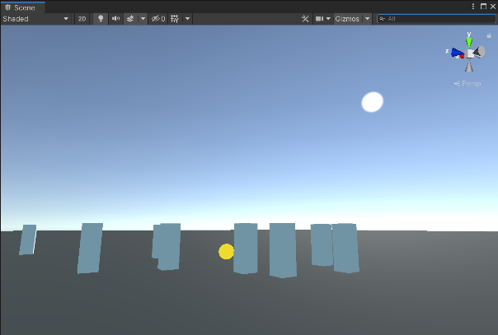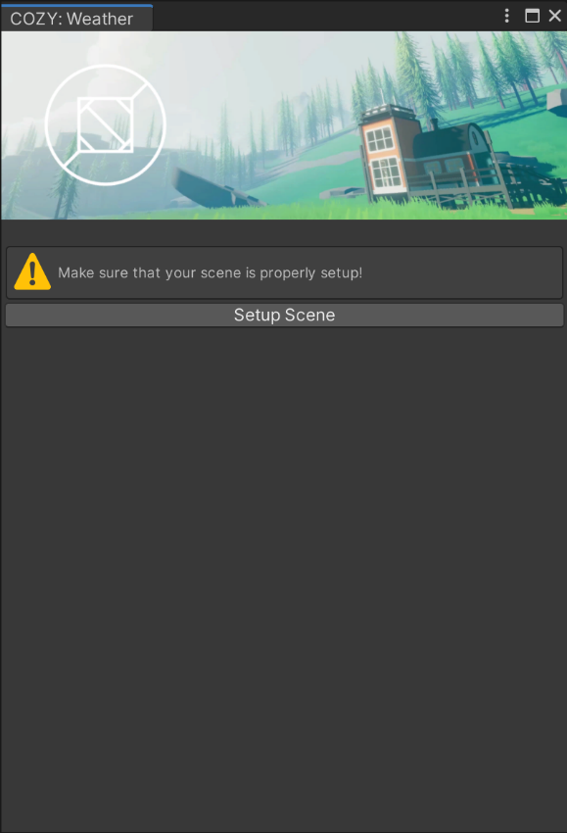

1. OPEN THE COZY EDITOR

Start by opening the COZY Editor in a scene that does not have an active COZY system already

____________________________________________

3. PRESS PLAY

And you’re done! Use the COZY editor to change parameters as you need.

By default, the COZY system will start up with all modules enabled and in desktop mode.

____________________________________________

2. CLICK SETUP SCENE

The window looks a bit different in an empty scene! All the tabs are gone and in their place is a big button that you should click right now.

____________________________________________

Note: you do need to have an active main camera for this step to work!

UNDER THE HOOD

____________________________________________________________________________

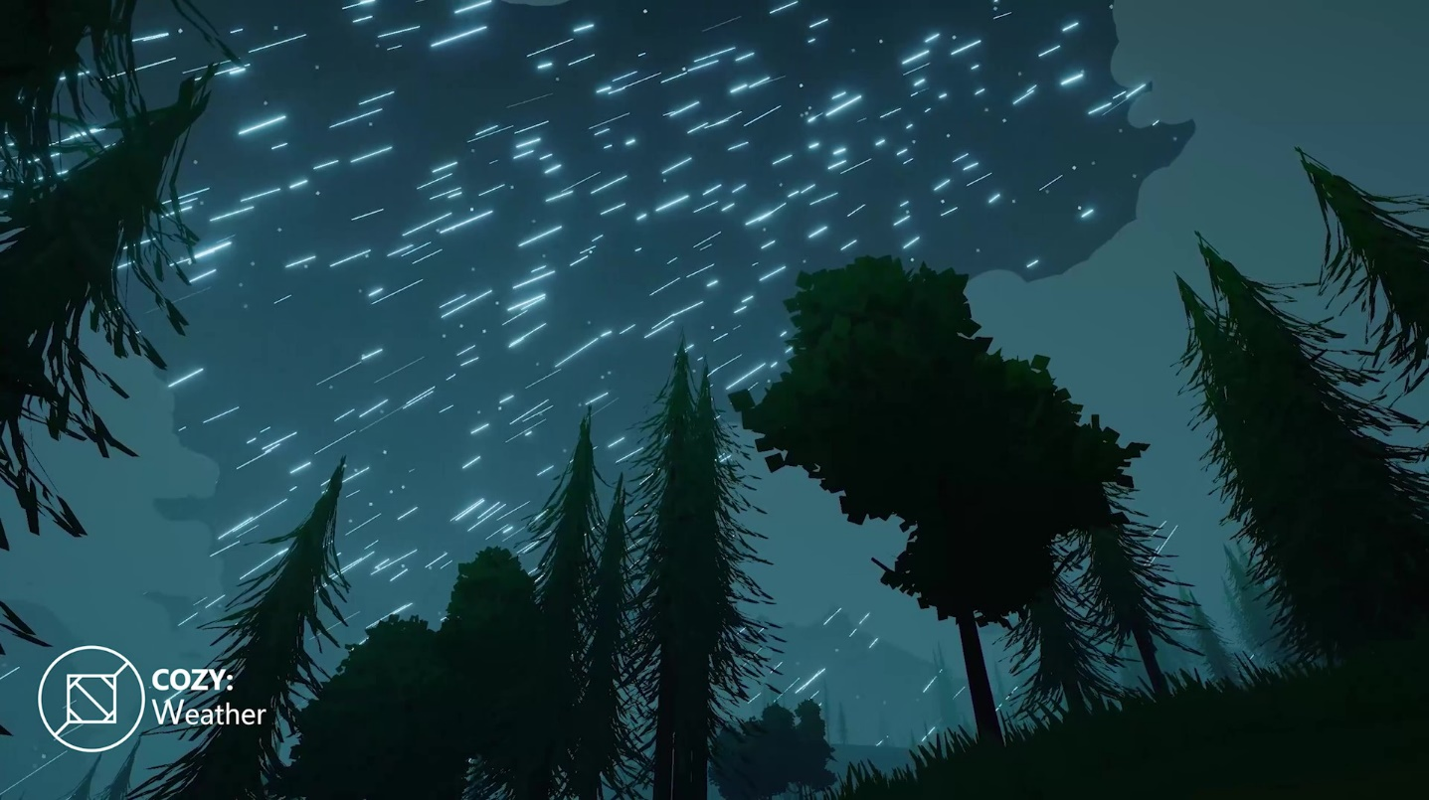

1. Introduction to Profiles

* What is a *Profile*?
* VFX Profiles

1. The Sky

* Skydome vs Skybox

1. The Clouds

* Intro to the Shader
* The Main Noise Functions

1. The Fog

* What is multi-layer fog?

Next up: Modules

WONDER HOW IT WORKS?

This section of the documentation touches on a few details for the individual rendering components that COZY uses.

________________________________________________________

INTRODUCTION TO PROFILES

QUICK TIP: Not all profiles are used by the main system. If you aren’t running any *modules,* you only need to use the Perennial, Weather, and Atmosphere Profiles!

____________________________________________________________________________

during prototyping without overriding the COZY: Weather game object.

COZY uses a network of scriptable objects we call profiles to control all the parameters at runtime. Check out the various profiles and what they do here! This allows you to easily save and load snapshots, make global changes during play mode, and safely save old versions

AMBIENCE PROFILE

Manages the particles, SFX and forecast patterns for an individual ambience.

ATMOSPHERE PROFILE

Manages the references for colors of lights, the skybox, fog, and clouds.



CLIMATE PROFILE

Manages the temperature and precipitation amount curves.

MATERIAL MANAGER PROFILE

References the materials that will change throughout the year.



WEATHER PROFILE

Manages settings for an individual weather pattern such as cloudy, sunny, heavy rain, etc.









SATTELITE PROFILE

Controls the physical references for a satellite in the COZY system.

FORECAST PROFILE

Holds the references to every Weather Profile that the COZY system will play.



PERENNIAL PROFILE

Manages all time related properties for COZY.



VFX PROFILES

QUICK TIP: To use VFX in COZY 2, you need an active VFX module!

____________________________________________________________________________

In COZY 2.0, VFX management was swapped to a generics-based profile system. With the new system, you can add FX profiles to a weather profile to enable that effect while the weather profile is playing.

The transition time curve dictates the transition for the FX profile. By default, a linear curve (or a flat line from (0, 0) to (1, 1) is used. Change the slope of the curve to change the rate that the effect will interpolate relative to the time transition.

PARTICLE FX

Particle FX manage the particles in your scene e.g., rain, snow, or dust.

POST FX

Overrides the current post processing using a custom volume. Requires the Post FX package for BiRP.



PRECIPITATION FX

Accumulates snow and rain puddles in the scene. Requires the use of the material manager.

THUNDER FX

Enables lightning and sets the time it takes for lightning to strike.



WIND FX

Sets wind speed and power.









FILTER FX

Recolor clouds, sunlight and fog based on an HSV adjustment as well as several color filters.

SOUND FX

Adds sound effects to the current weather profile.



MULTI FX

Plays various FX profiles depending on the time of day. Use these to play certain sounds in the morning and other sounds in the evening.



THE SKY

____________________________________________________________________________



COZY’s sky dome is made up of 3 major sections: the main sky, the clouds, and the fog. Each of these sections have multiple subgroups that affect the way that the whole is interpreted.

_________________________________________________________________

The first subgroup of the main sky is a simple gradient shader that interpolates between the zenith and horizon of the sky. This is modified by the atmosphere variation property to create a more varied and visually interesting sky.

_________________________________________________________________

The next subgroup dictates celestial parameters or put more clearly, settings for the sun. Change the direction, color, size, and falloff of the sun here!

_________________________________________________________________

The last major subgroup deals with other light FX. Star colors, galaxies, light columns, and more are managed here. All of the FX are additive so if you would like to disable any of them, simply set their color to black and they will disappear!





THE CLOUDS

CUMULUS CLOUDS

The default clouds for COZY. Big, fluffy, Voronoi noise patterns that lead to stylish skies!

____________________________________________________________________________

The next section of COZY’s sky dome is the cloud sphere. This is one of the most distinctive sections of COZY that separates it from other weather systems. COZY ships with 7 different cloud algorithms that all combine to make a varied and stylish sky!



NIMBUS CLOUDS

Amends the cumulus algorithm allowing storms to envelope your world giving players a sense of warning

CHEMTRAILS

Staples of anime style skies, the chemtrails algorithm emulates the moisture left by jet trails.

CIRROSTRATUS CLOUDS

Noisy high-altitude clouds that signify cold temperatures, low humidity and heavy wind.



ALTOCUMULUS CLOUDS

Super high-altitude clouds that can add a touch of detail to your scene.

BORDER CLOUDS

Set your scene with a ring of clouds around the horizon! Set the effect in the negatives to remove clouds rather than add them!

CIRRUS CLOUDS

Windswept stylish clouds that can add a touch of flavor to otherwise clear skies

THE FOG

QUICK TIP: This style of fog shader is inspired by several influential games such as Firewatch and Among Trees. For more ideas and use cases, check out their results!

____________________________________________________________________________



The fog dome is the true hero of COZY: Weather and provides most of the color dynamic and atmosphere.

The fog dome is a combination effort between a traditional false height fog, a sunlight flare halo, and a gradient-based stylized linear fog.

The height-based portion fades the fog into the sky creating an illusion of a large atmosphere. The smoothness, intensity and offset of the fog can be tweaked to create different atmosphere types.

The sun flare provides a ton of atmosphere by additively changing the color of the fog in the direction of the sun. This effect simulates certain aspects of volumetric fog at half the performance cost!

The linear stylized fog is a simple gradient composed of 5 colors (alpha controls density) that are controlled by the COZY head unit. Instead of mathematically calculating the most realistic fog parameters, COZY passes the depth into the gradient to come up with a color and density to render on a per-pixel basis.

This gradient allows you to easily have layers of color that all pop but still co-ordinate with each other. For example, while the fog in the background of the scene is a vibrant orange, the fog on the trees in the foreground are a deep purple

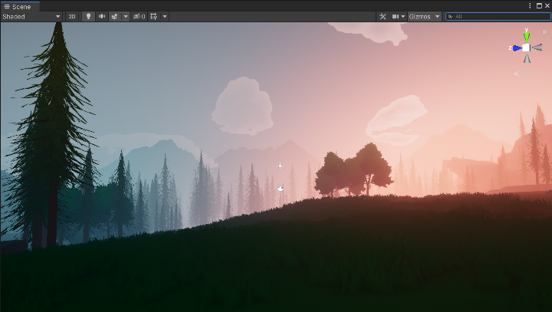

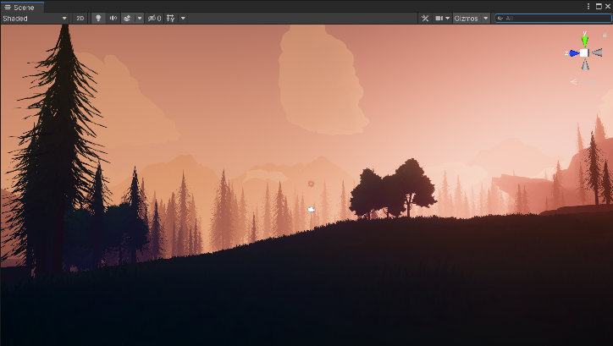

MODULES

____________________________________________________________________________

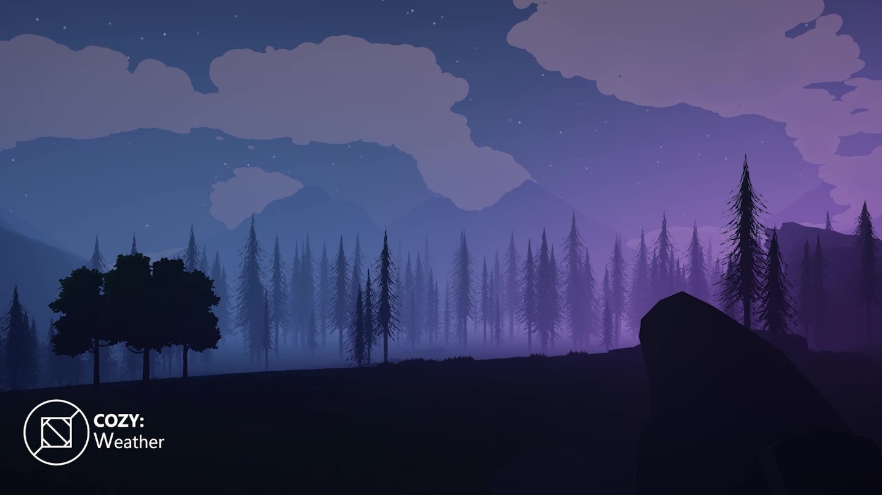

1. Managing Modules

* How to Use the Onboard Modules
* Adding and Removing Modules

1. Module Overviews

* Material Manager
* VFX Module
* Ambience Module
* Satellite Module
* Events Module
* Save & Load Module
* Reports Module

Next up: Integrations

CUSTOMIZE FUNCTIONALITY

The **module system** is a very simple and effective way to customize your COZY system.

Expand functionality by adding and removing modules to create the best balance between performance and results.

________________________________________________________

INTRODUCTION TO MODULES

____________________________________________________________________________

Not all Unity projects are built the same and COZY is built to honor that! COZY uses a series of *modules* or scripts that add to the initial code loop that runs. There are 4 base modules that handle the basic functions, and many extension modules that you can add depending on the needs of your project!

The first three modules (Atmosphere, Time, and Weather) are the most important pieces of the COZY system.

* The **ATMOSPHERE MODULE** controls the colors and properties of the sky, fog, and clouds.
* The **TIME MODULE** controls the time related properties such as the current time of day, as well as day length, year length, etc.
* The WEATHER MODULE controls all weather-related properties, from forecasting to ecosystem properties to setting the current weather.

All three of these modules can be set to run via profile or natively (called manual and ecosystem on the weather module). When run in PROFILE MODE, COZY will pull from a static property set known as a profile allowing for scene persistence. In NATIVE MODE, COZY will store properties in the game object data, allowing for you to set up scenes with completely different atmospheres while using the same profiles. Check out more modules in the ***MODULES*** section!

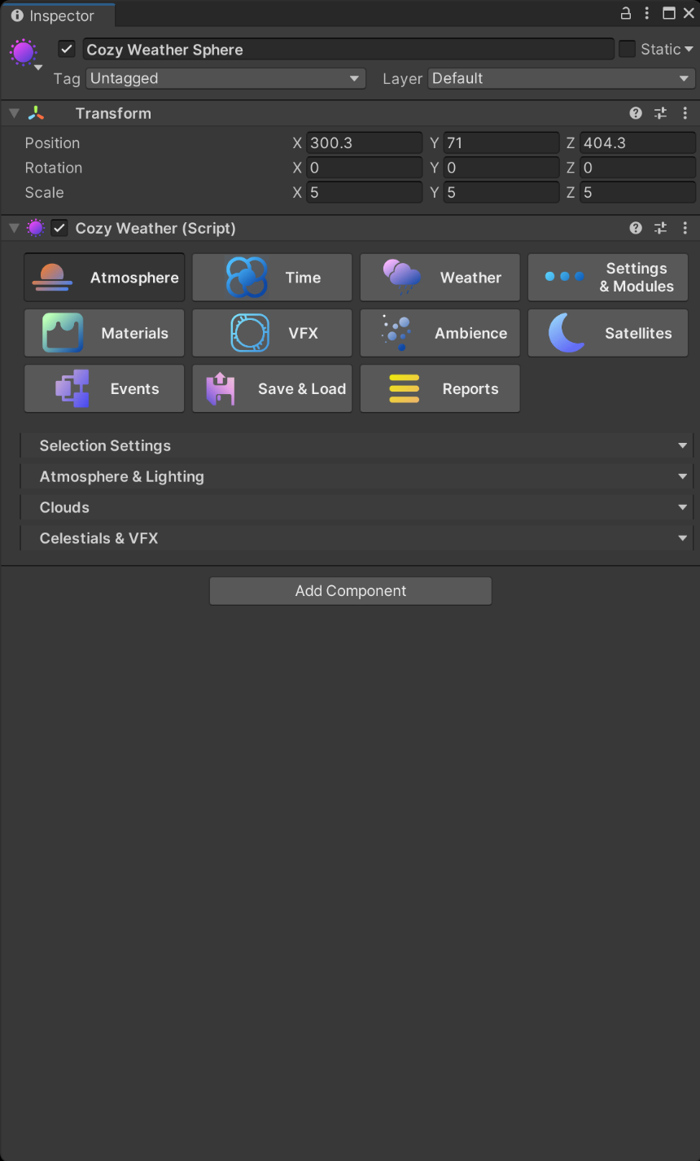

The last tab (Settings & Modules), is used to manage all the miscellaneous properties of your system. You can add/remove modules, setup render style parameters, and even toggle tooltips in this tab!

MATERIAL MANAGER MODULE

Modulate material values,

terrain layer colors and global

shader values by built in ratios

____________________________________________________________________________

The **MATERIAL MANAGER MODULE** controls all material and shader-based modulation based on COZY’s properties. Use this module to simulate snow accumulation, leaves turning autumnal colors, grass drying and growing, leaves falling from trees, puddles forming during rain and more!

* Setup a property to modify in the **MODULATED VALUES** section. The first enum dictates the modulation target (material, terrain layer, global shader, etc) and the second enum refers to the source to base the modulation from (time of year, time of day, how much snow is on the ground, etc).
* The MAPPED GRADIENT/CURVE controls the value that will be passed to the modulation target at the percentage dictated by the modulation source. For example, if you want to add snow accumulation to a material, you might set the modulation source to snow amount and the gradient to green at 0% and white at 100%.
* The GLOBAL SETTINGS tab allows you to set references for global snow and puddles. These ONLY control the global shader properties used by COZY materials!
* The OPTIONS TAB allows you to manually set snow and rain amounts as well as the deaccumulation speed.

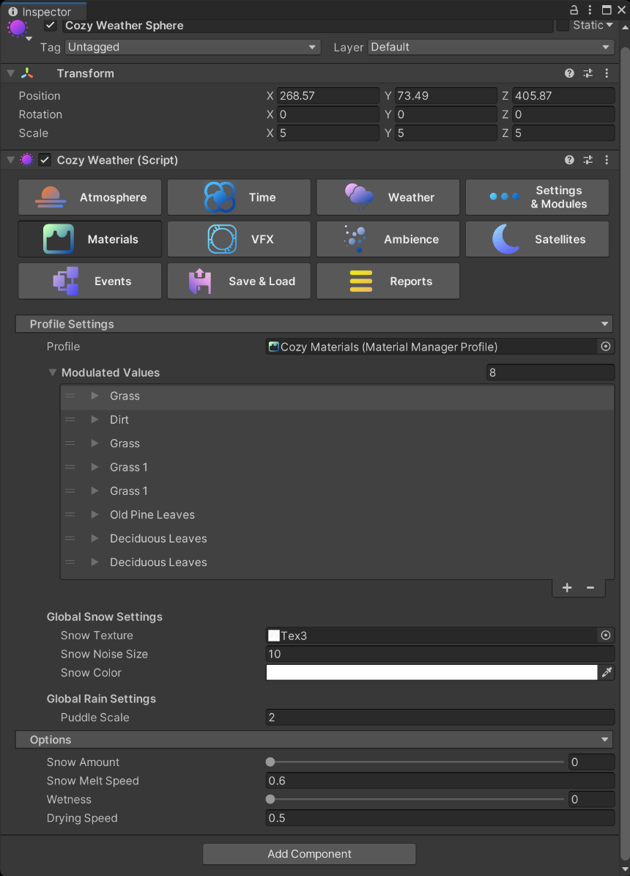

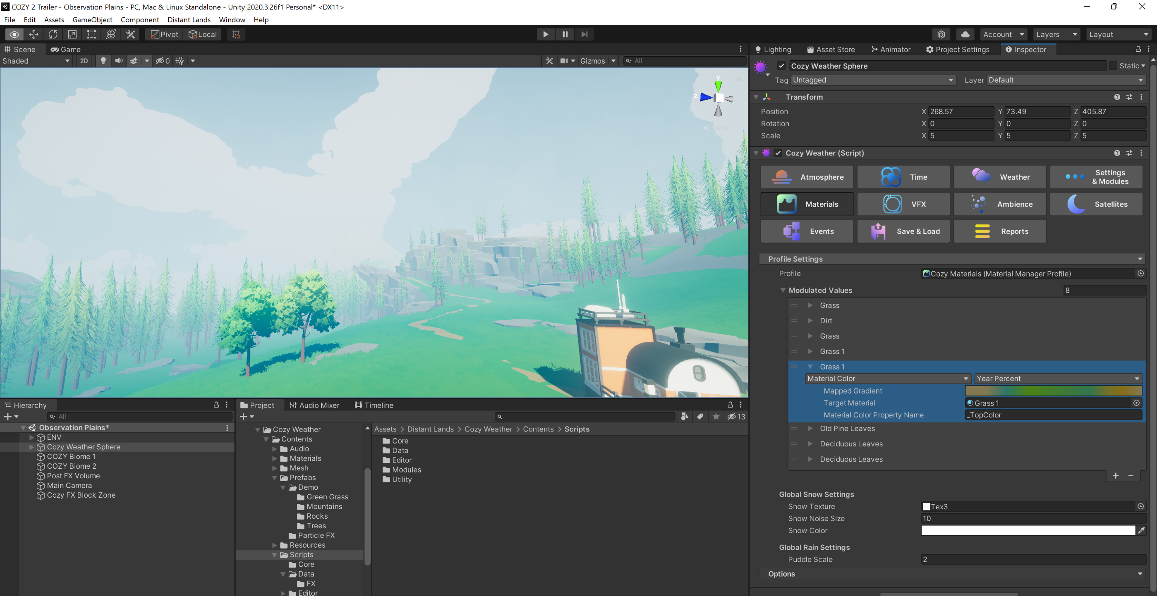

VFX MODULE

Control and disable VFX

____________________________________________________________________________

The **VFX MODULE** controls all VFX that is used by COZY.

* PARTICLE FX controls any particle FX that spawn in your scene to be used by COZY. Rain, snow, hail, dust, and more are all controlled here! Use the multiplier to control the number of particles that spawn (0 disables and 2 doubles the normal amount).
* AUDIO FX holds references to any audio effect that the COZY system will play. The volume multiplier will change the default volume of the effects by the slider value.
* POST PROCESSING FX allows you to override the current post processing settings.
* PRECIPITATION FX controls the rate of accumulation for snow and rain. Use the multiplier slider to control the rate at which precipitation accumulates.
* THUNDER FX (previously known as lightning FX) manages the visual lightning effects and the audio clips played by the thunder sounds.
* WIND FX manages the visual wind effects used in COZY. You can set it to use either wind zones, shader-based wind or both!

You can also set up LINKED PARTICLE SYSTEMS that pull their coloring from either the cloud color or the star color if you want to extend the VFX of the system with your own FX!

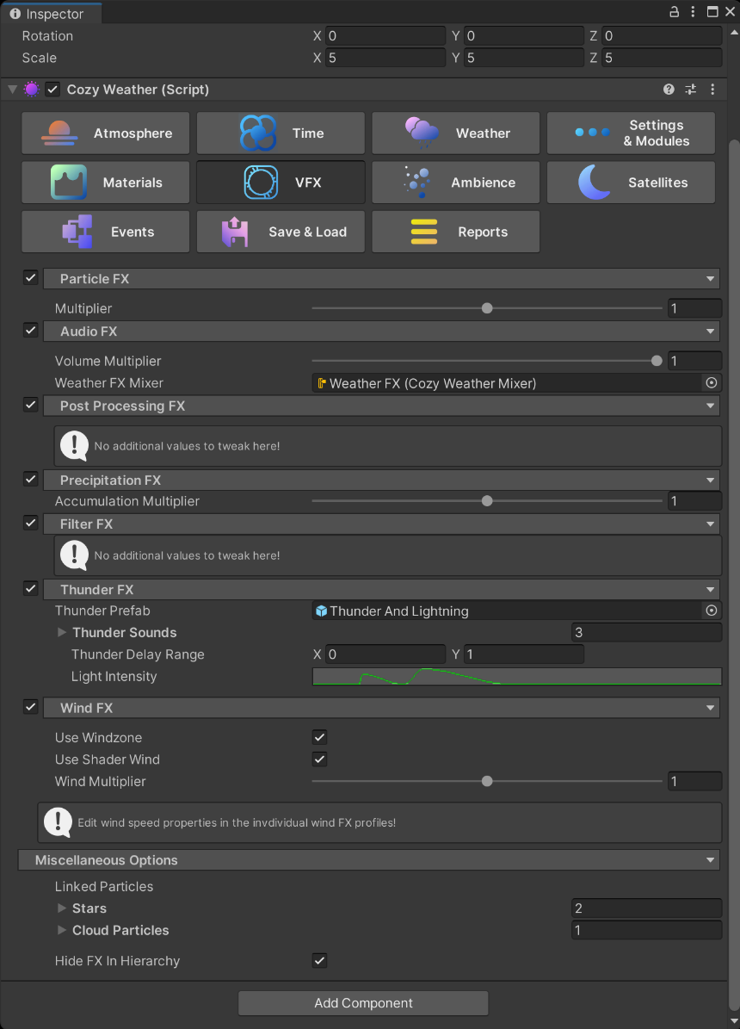

AMBIENCE MODULE

Manage a secondary ecosystem

designed as a light addition to

the main system.

____________________________________________________________________________

The **AMBIENCE MODULE** works as a lighter, secondary ecosystem that controls ambient particles, sounds, and other FX.

* Set the ambience profiles that you want to forecast in the FORECAST SETTINGS tab.
* Change the current ambience profile using the CURRENT AMBIENCE PROFILE.

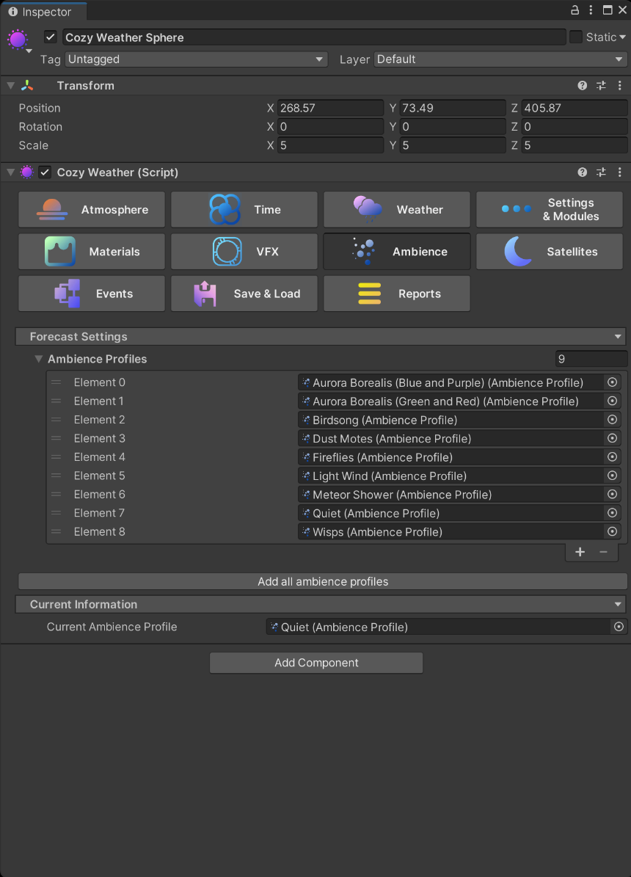

SATELLITE MODULE

Controls the moons and satellites

used by the COZY system.

____________________________________________________________________________

The **SATELLITE MODULE** controls all of the orbiting satellites and moons that sync with the COZY weather system. Setup your individual moon parameters in the satellite profiles.

* The **HIDE IN HEIRARCHY** toggle shows or hides the satellite game objects in the scene. Use this to debug your satellites!
* The first satellite in the list functions as the MAIN MOON for the system and influences the moon halo effect on the sky.

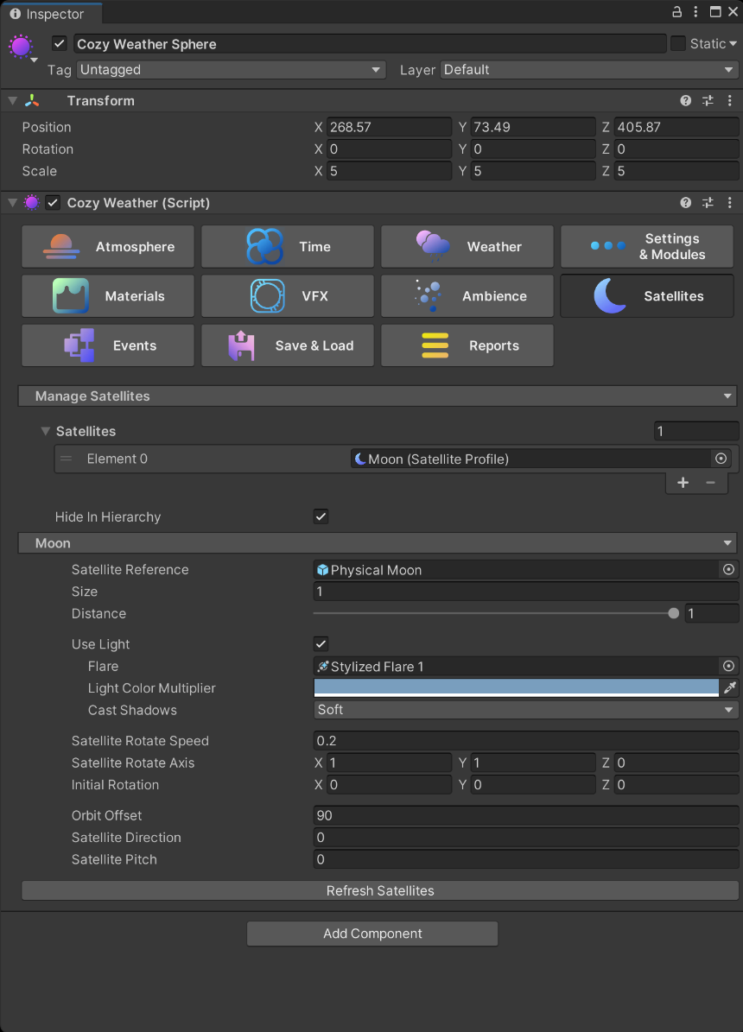

EVENTS MODULE

Controls events that tie into COZY.

____________________________________________________________________________

The **EVENTS MODULE** allows you to trigger Unity Events at integral moments within the COZY system. This system allows you to create more interactivity between COZY and your game. For example:

* Set a method that triggers in the ON EVENING event that turns on lights in your scene when it gets dark.
* Trigger a bell tower ringing event using the ON NEW HOUR event.
* Trigger an event that displays the current day on-screen in the ON NEW DAY event.
* Trigger an event that displays the current weather using a function in the ON NEW WEATHER event.

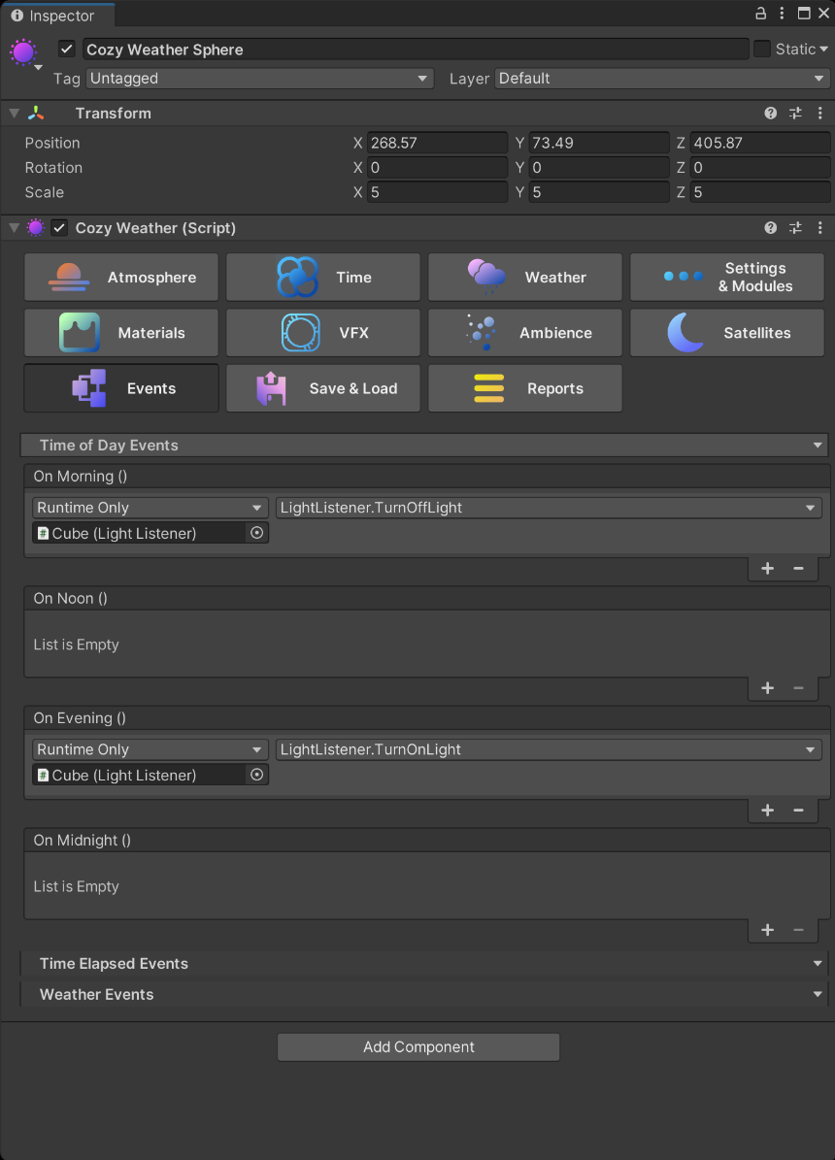

SAVE & LOAD MODULE

Save and load your system to a JSON.

____________________________________________________________________________

The **SAVE & LOAD MODULE** allows you to save your current COZY settings to a JSON file. This JSON file is then stored in the Player Prefs. Use the Save and Load functions to pull the data from the Player Prefs when you save and load your game.

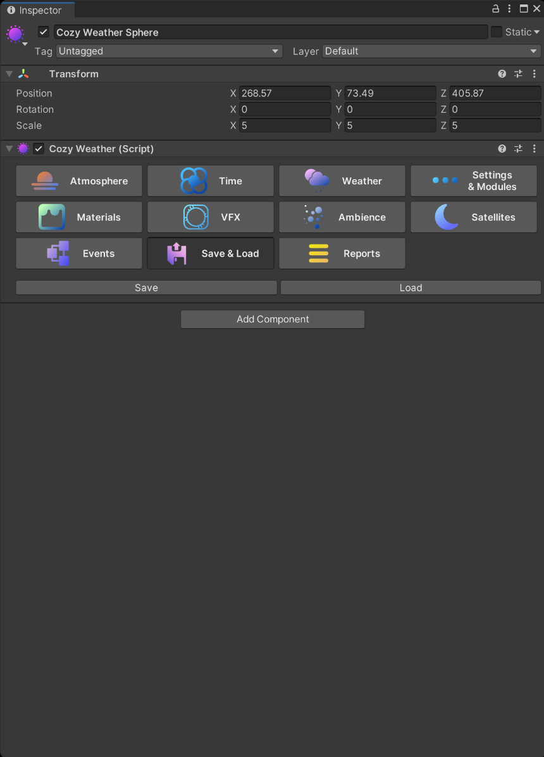

REPORTS MODULE

View the current status of COZY.

____________________________________________________________________________

The **REPORTS MODULE** does not control any external properties, but instead provides a source from which you can view the individual properties that are being controlled by the COZY system at one time. Accessible here is the current time, date, temperature, humidity, and forecast!

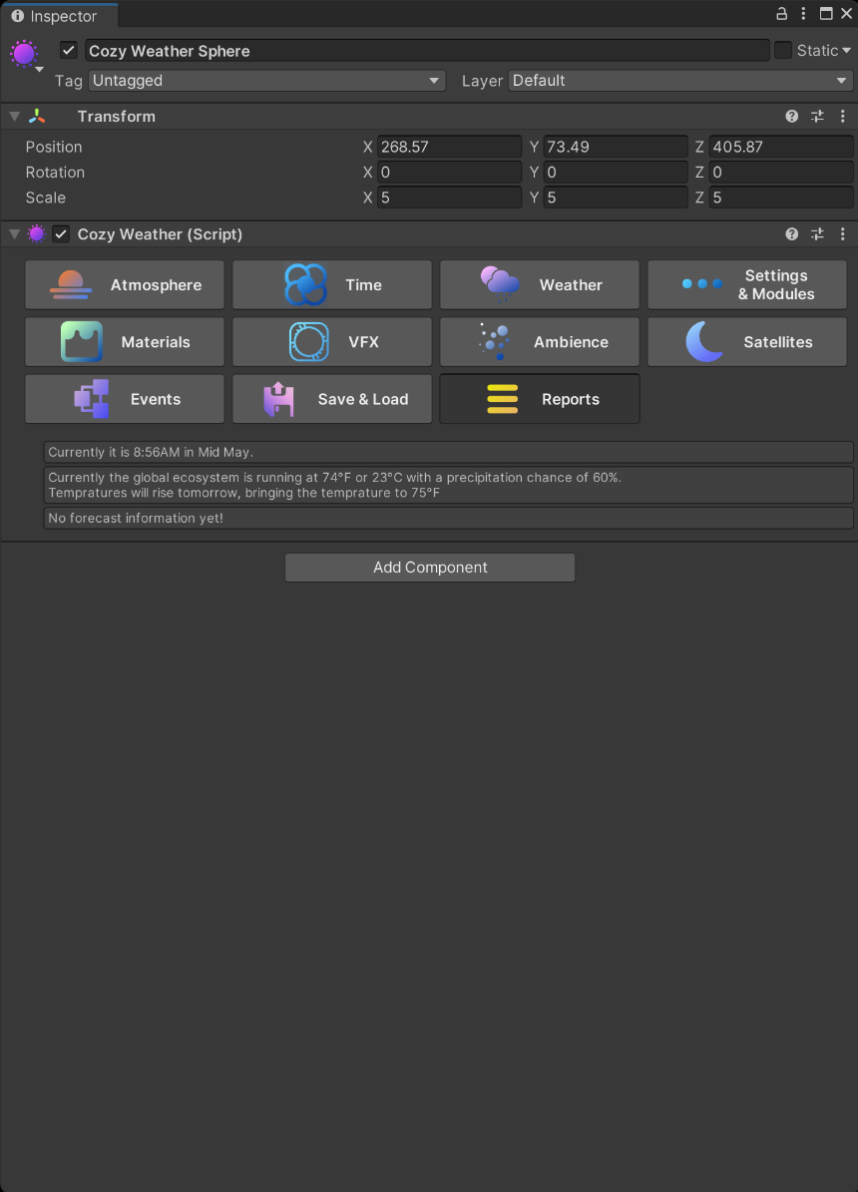

INTEGRATIONS

____________________________________________________________________________

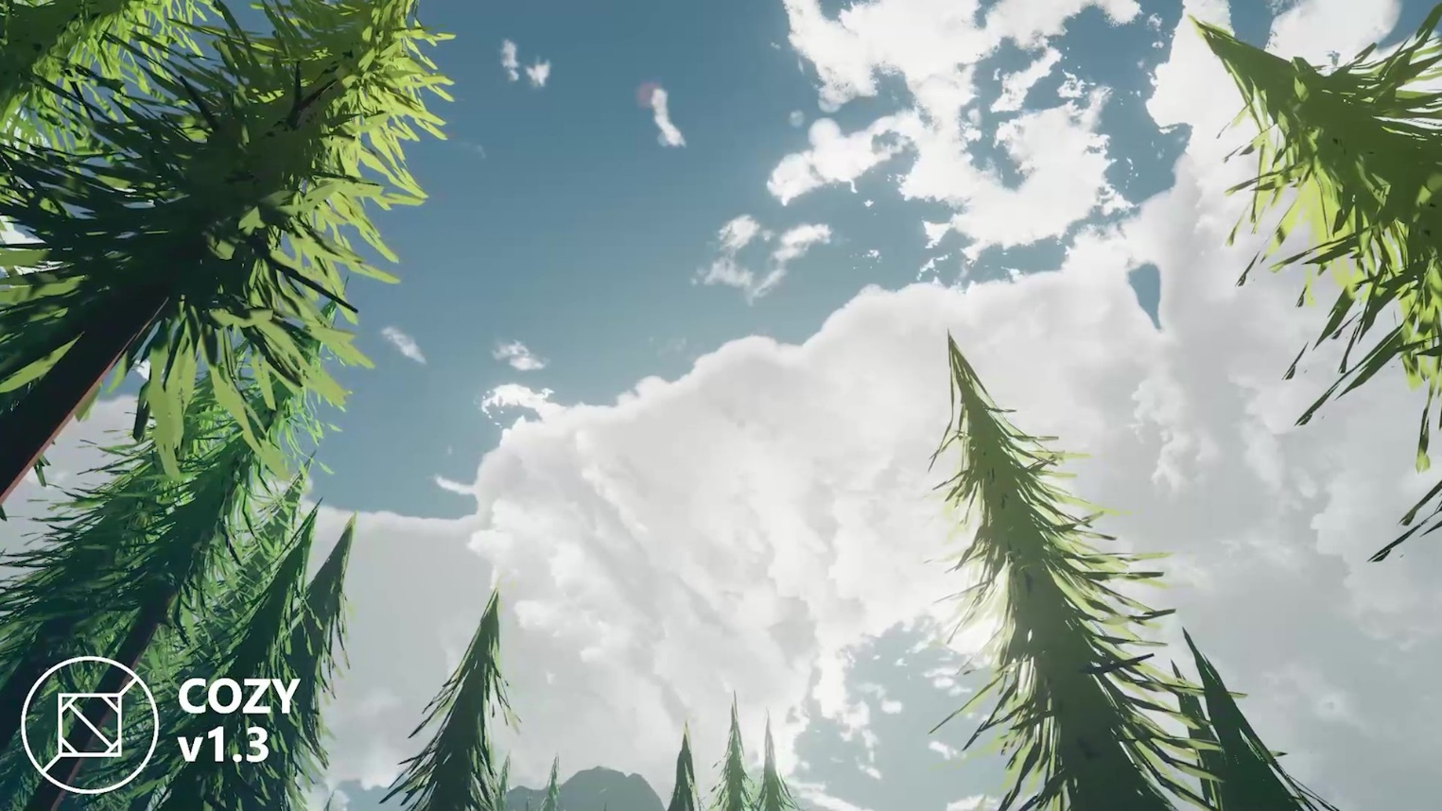

1. Water Integrations

* Crest Ocean
* Stylized Water 2

1. Script Integrations

* The Vegetation Engine

Next up: Coming Soon

EVERY PROJECT IS UNIQUE

COZY ships with many tools to help you with integrations and customization. Let us do the heavy lifting when it comes to making your project work so that you can have infinite freedom to explore your weather system!

________________________________________________________

CREST INTEGRATION

____________________________________________________________________________

Follow these simple steps for Crest Ocean support with COZY: Weather! Note that these steps only work in v1.4+

To start the integration, open the Ocean.shader file. Then find the blue line and add the yellow code.

Cull [_CullMode]  
**Stencil  
{  
     Ref 222 //Set to 221 in URP  
     Comp Always  
     Pass Replace  
}**

____________________________________________

#include "Lighting.cginc"  
**#include "Assets/Distant Lands/Cozy Weather/Contents/Materials/Shaders/Includes/StylizedFogIncludes.cginc"**

____________________________________________

BiRP

if (!underwater)  
{

     //UNITY_APPLY_FOG(input.fogCoord, col); **col = BlendStylizedFog(input.worldPos, half4(col.xyz, 1));**  
}

URP

if (!underwater)  
{

     //UNITY_APPLY_FOG(input.fogCoord, col); **col = BlendStylizedFog(input.positionWS_fogFactor, half4(col.xyz, 1));**  
}

STYLIZED WATER 2

INTEGRATION

____________________________________________________________________________

SW2 is now directly integrated with COZY! Simply select COZY from their onboard integrations to automatically modify the water shader!

THE VEGETATION ENGINE

____________________________________________________________________________

COZY comes with TVE integration out of the box; all you have to do is add the module to your system and you are good to go! First setup your scene for TVE and for COZY and then follow these two steps to allow COZY to take control of your TVE objects.

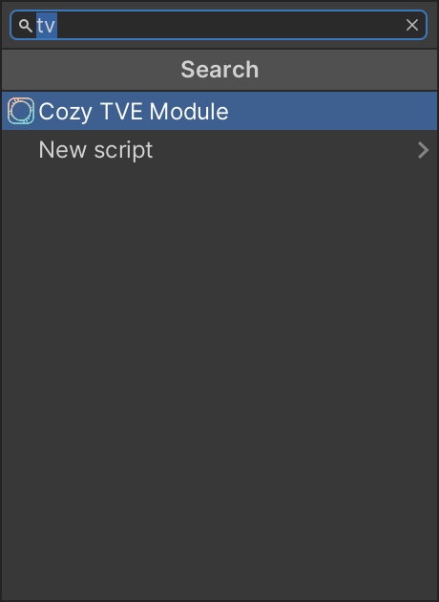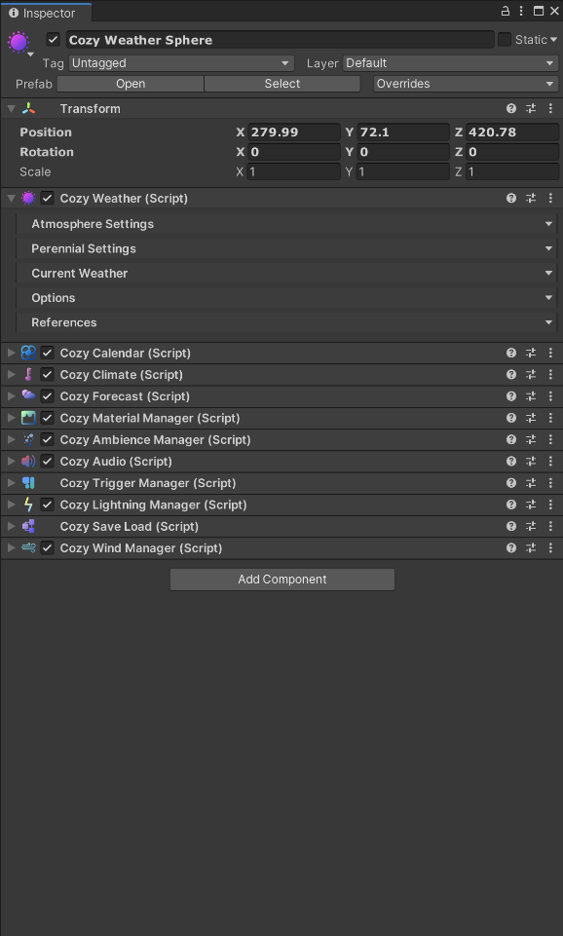

2. ADD THE TVE MODULE

Now search for the Cozy TVE Module and add it to your system. This module sends all of COZY’s information to The Vegetation Engine.

____________________________________________

1. SELECT THE COZY SYSTEM

Select your COZY system in the scene view. Next scroll all the way to the bottom of the inspector and hit the add component button.

____________________________________________

Note: setup your TVE scene first!

MICROSPLAT

____________________________________________________________________________

COZY comes with MicroSplat integration out of the box; all you have to do is add the module to your system and you are good to go! First setup your scene for MicroSplat and for COZY and then follow these two steps to allow COZY to take control of your MicroSplat shaders.

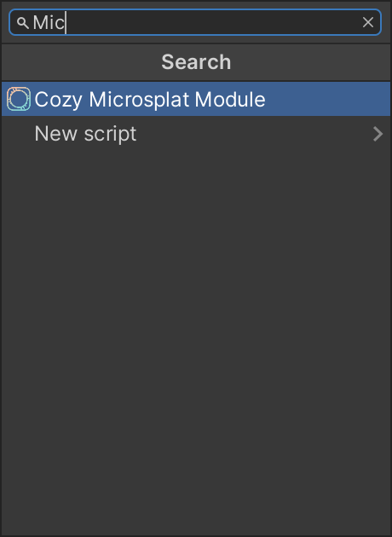

2. ADD THE MICROSPLAT MODULE

Now search for the Cozy Microsplat Module and add it to your system. This module sends all of COZY’s information to the global shader properties used by MicroSplat.

____________________________________________

1. SELECT THE COZY SYSTEM

Select your COZY system in the scene view. Next scroll all the way to the bottom of the inspector and hit the add component button.

THIS DOCUMENT IS WORK IN PROGRESS

We plan on expanding this documentation in the near future however extenuating circumstances have

made that more difficult than we initially realized. Next on the to-do list is customization and API docs.

Thanks for your patience!